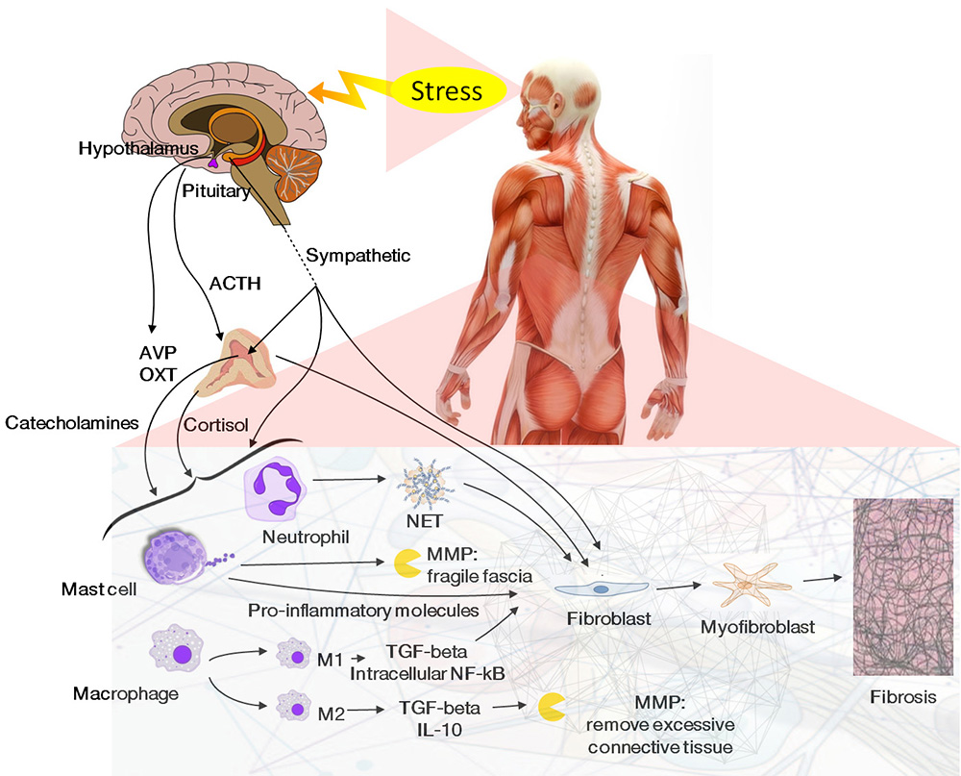
Figure 1. The relationship between stress axis, immune system, and fascia: the activation of the HPA axis stimulates the adrenals to release catecholamines and cortisol. These hormones, together with the activation of the sympathetic nervous system caused by stress, stimulate immune cells inside the fascia. Based on the intensity of the stimulus, macrophages, mast cells, and neutrophils release molecules that can influence the structure of the fascia.

Figure 2. Cells can change their phenotypes when stimulated. Endothelial, epithelial, and mesenchymal cells can become fibroblasts due to the effect of inflammatory cytokines, mechanical stress, and extracellular pH; other stimuli such as hyperglycemia and surgery can also induce this phenotype shift since they increase inflammation and mechanical stress. These same stimuli – in particular, TGF-beta1, mechanical stress, and ROS – can elicit fibroblasts and many cells to become myofibroblasts: they can produce contraction since they show a high concentration of alpha-SMA fibers. Fibroblasts and myofibroblasts appear when the organism needs to increase the production of extracellular matrix and to heal a wound: psychophysical stress can facilitate the induction of these cells through the secretion of cortisol and catecholamines, which can increase inflammatory cytokines and ROS. Myofibroblasts can de-differentiate back into their original phenotype through interventions that can reduce the mechanical stress and the inflammation level, or that can activate factors such as PPAR-gamma and Nrf2: some example are caloric restriction, physical activity, manual therapies, and antioxidants.
